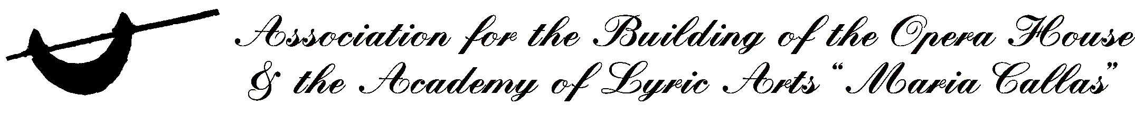

Master Class: June 7-9, 2010, Parnassos Literary Society Hall, 8 Karytsi, St. George Square, Athens.
Open to lyric artists, soloists and choirs.

Audition: June 5 & 6, 2010. The place to be held will be announced by 1st of April 2010.

Gala concert: June 10, 2010, Parnassos Literary Society Hall, 8 Karytsi, St. George Square, Athens.
With selected participants from the master class of Luciana Serra.

Registration form

Name:…………………………………………………………………………………
Middle name, Surname:………………………………………………………………
Date of birth:………….Place of birth:………………Nationality:…………………..
ID No:……………………………………………………………………………….
Address:………………………………………………………………………………
E-mail, web:………………………………………………………………………….
Tel:………………………………Mobile:…………………………………………..
Music Education……………………………………………………………………..
Vocal trainer………………………………Voice……………………………………
I wish to apply for the international master class with Luciana Serra as:
1. active participant
2. course attendant

Repertoire: 1…………………………………………………………………....
2…………………………………………………………………....
3……………………………………………………………………

Application documents (enclosed)
- Application form
- Signed Participation Terms & Conditions form
- Copy of diploma for completed education (optional)
- Professional CV and CD recordings (demo)
- Photo

Application deadline: May 21, 2010

Fees:
Audition: 20 euro
Active Participantion: 300 euro
Course attendance : 150 euro

The fees for the audition and participation are payable at the Association’s Office, 21 Lycavvitou str., 10672, Athens, Tel: 2103634868 Fax :2103620844, www.orama-opera.gr
or via bank transfer: ALPHA BANK GREECE, IBAN: GR42 0140 1030 1030 0232 0004 792, BIC: GRBAGRAAXXX Beneficiary: Association for the building of the Opera House & the Academy of Lyric Arts “Maria Callas”.

